Problem 1

Implement the use case present in below blog link and share the complete steps along with screenshot(s) from your end.

NOTE: You must submit a word file containing steps and screenshots.

Pig file:



Screen shot :

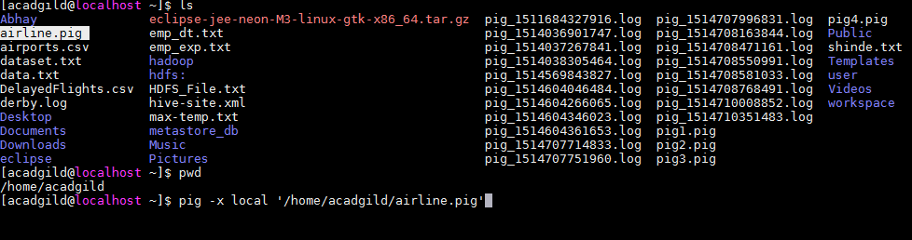

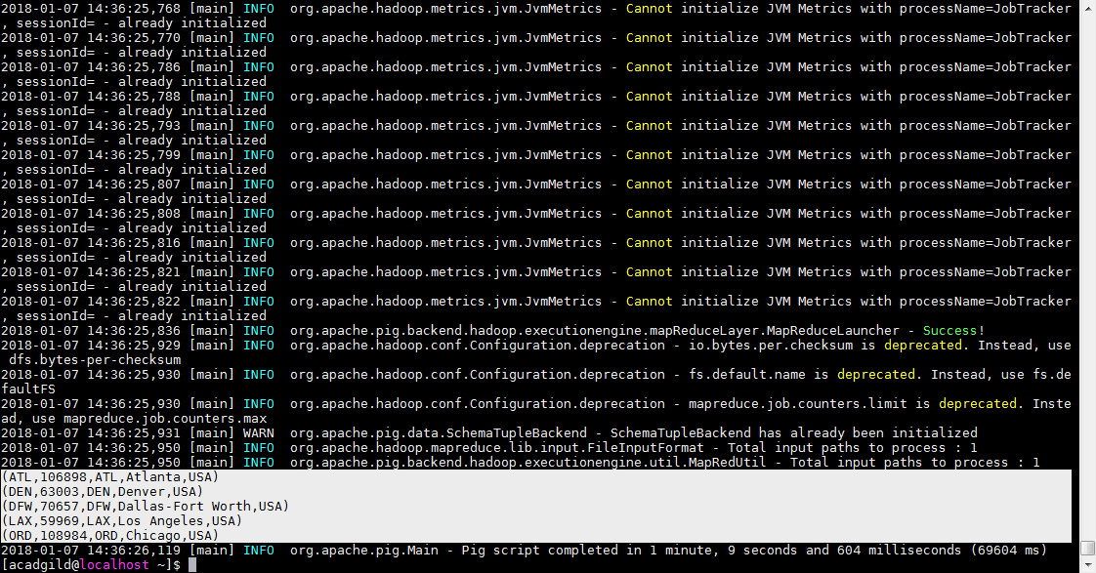

Problem 2:

Pig file :



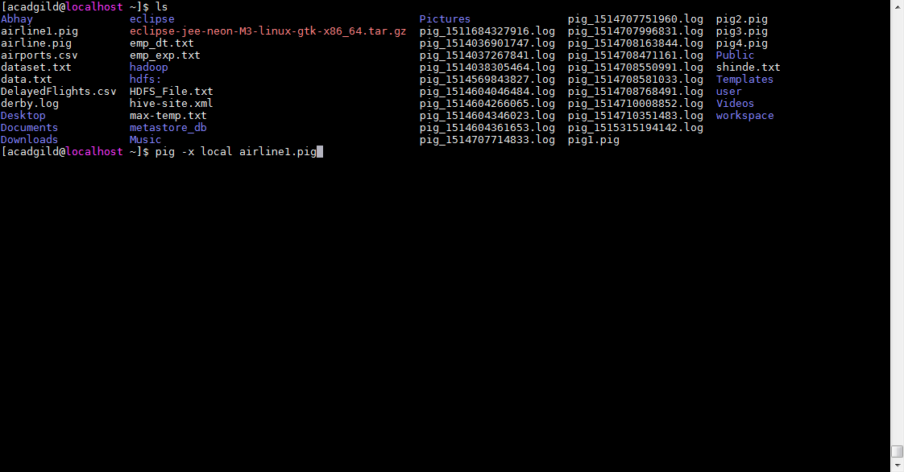

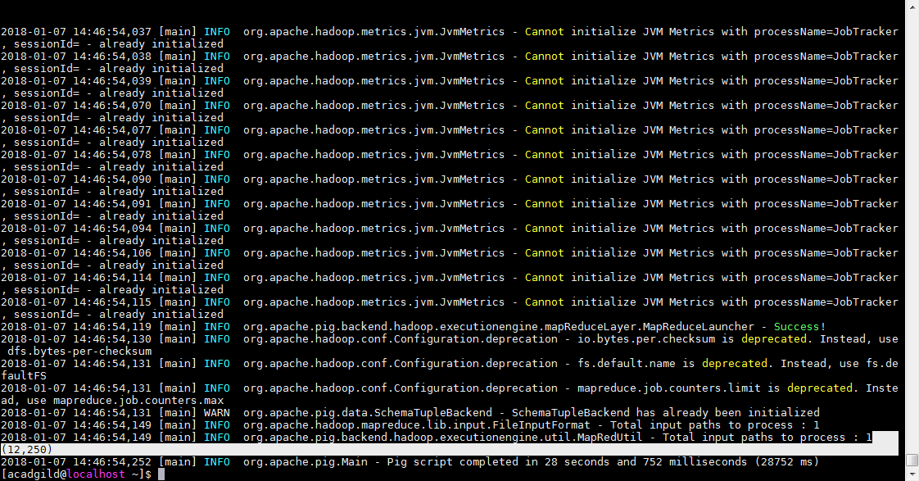

Problem 3 :

Pig file :



Screen shot:

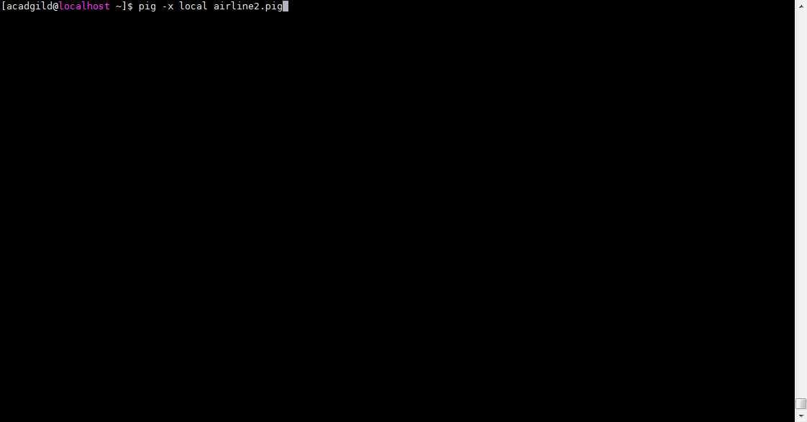

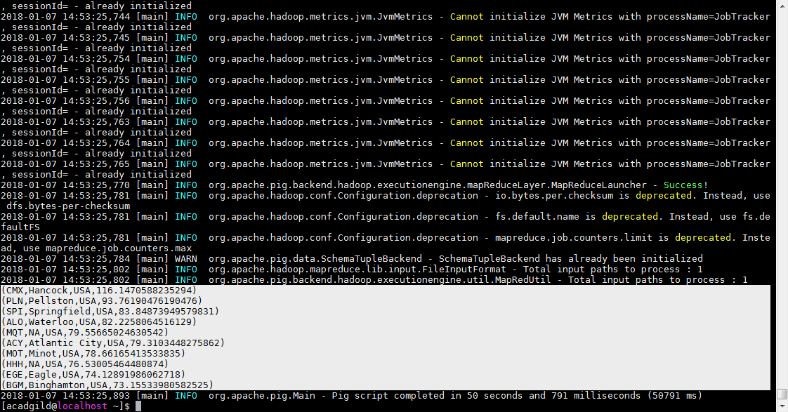

Problem 4:

Pig File :



